Elizabeth Hawkins

245-Linux Administration

Continue Setup for CentOS 7

11/4/2021

In this lab there are a couple of things you need to install on your system to get it up and running. I will be installing Tmux, emacs, Fail2ban,cowsay,lolcat, and updating VI to Vim. To install these things on your CentOs server you will use the sudo yum command to install the programs.

The first thing we need to know before you continue installing on our server is how to set up our server and to make sure you have all the permissions to install all the programs you will be required to make the user root. To do that you run the command su root on the server.

The first application we need to install is Tmux.

Tmux is an open-source terminal multiplexer for Unix-like operating systems. It allows multiple terminal sessions to be accessed simultaneously in a single window. It is useful for running more than on command-line program at the same time.(google.com)

Step 2 install emacs

Emacs is a text editing tool that comes out-of-the-box with Linux and macOS.

To install Emacs you use the command sudo yum install emacs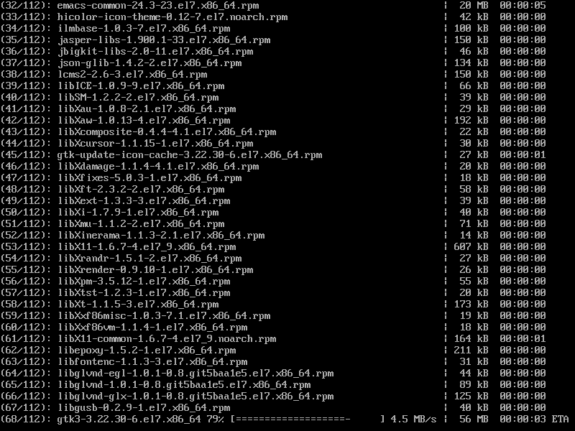

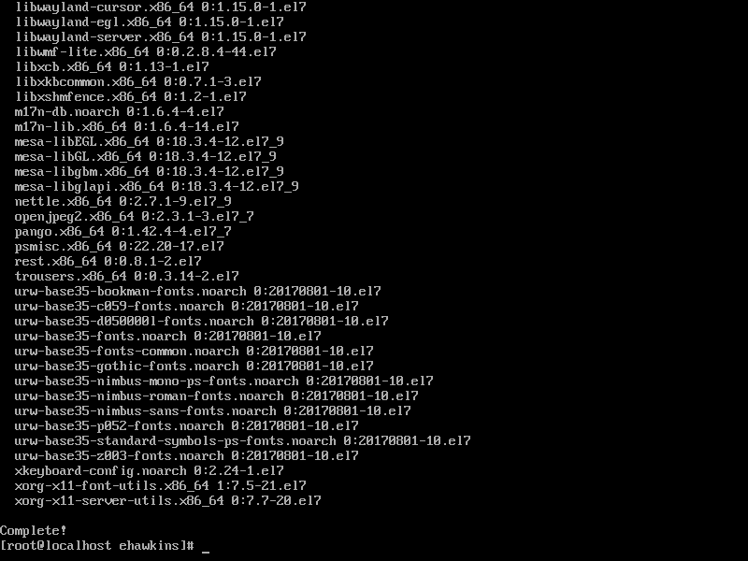

Step 3 Install Fail2ban

When you run the command for fail2ban it says no package for fail2ban available this is because fail2ban runs on a repository, so we need to add the correct repository. Fail2ban runs on a epel-release repository so we need to install that first before we can install fail2ban.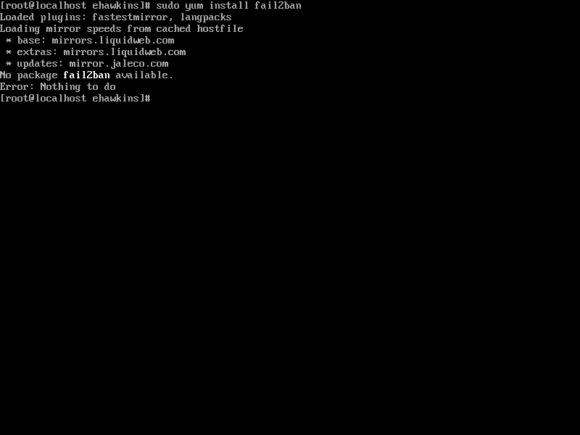

To install the epel-release repository you run the command sudo yum install epel-release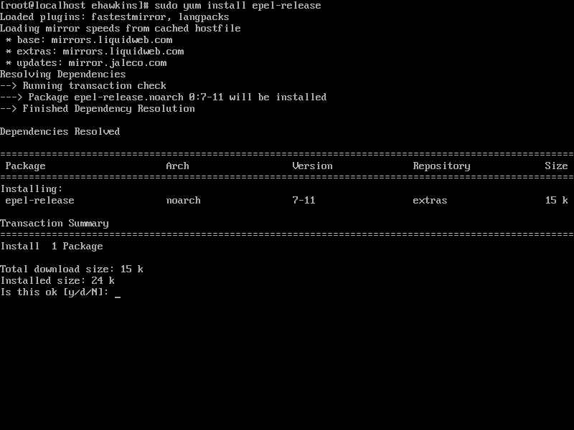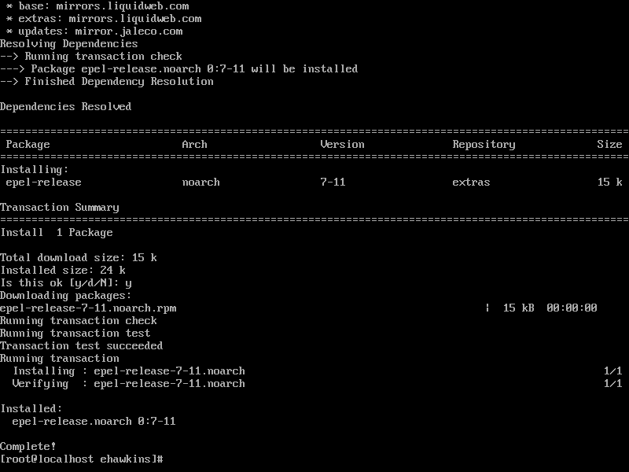

Step 4 Install Cowsay

Cowsay is a program that generates ASCII art pictures of a cow with a message.(Google.com)

To install cowsay you use the command sudo yum install cowsay.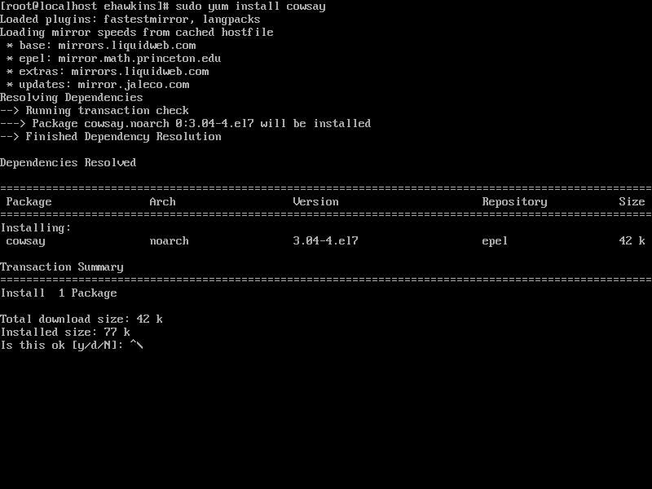

After you finish with the installation of the cowsay we must test it to see if our installation works properly. To test to see if the installation works properly, you run the command cowsay test.

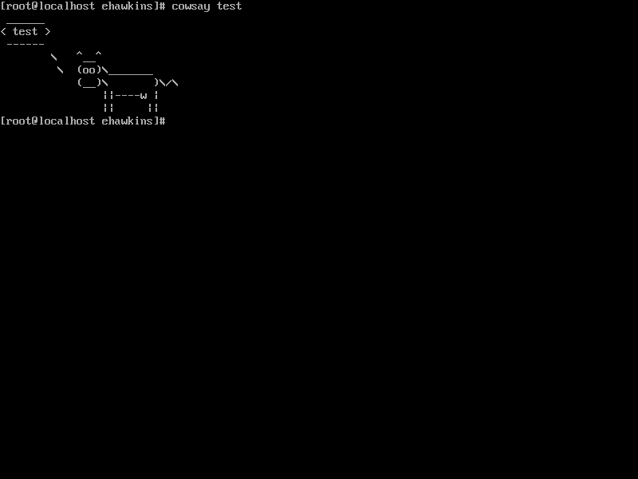

To check the location of where Cowsay is installed you run the command which cowsay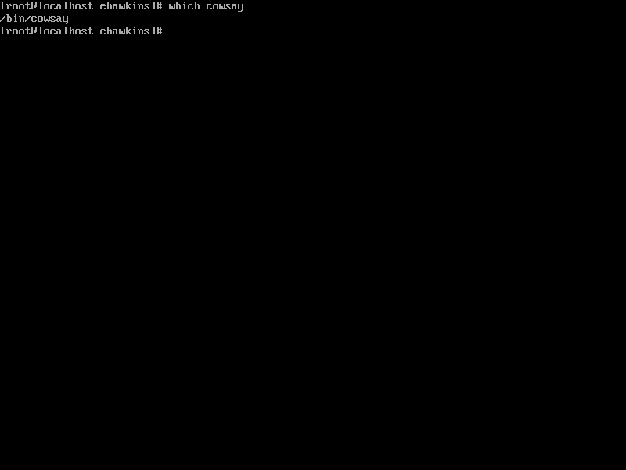

Step 5 Install lolcat

Lolcat is a utility for Linux, BSD and OSX which concatenates like similar to cat command and it will allow you to have colors on it.

To install lolcat you run the command sudo yum install lolcat. When you run the command, it says No package lolcat available. It is this way because lolcat needs a ruby to be installed before you can run lolcat. To do this you must run the command sudo yum install ruby.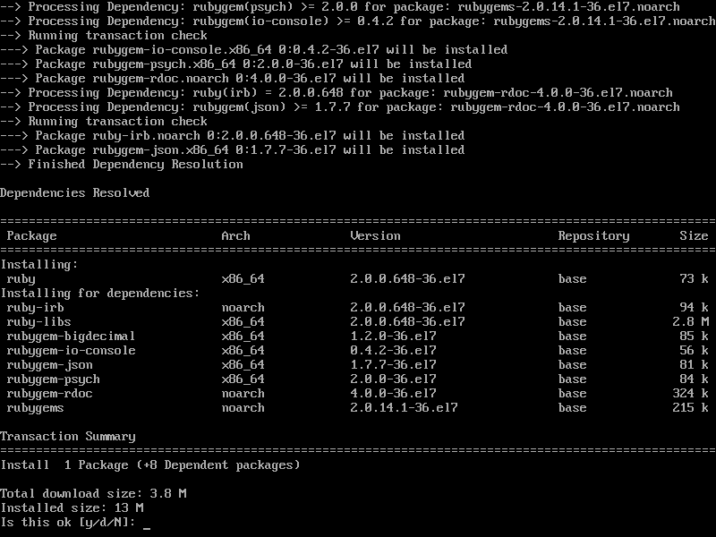

After that is done, we must download the lolcat zip file using wget. To do that we use this information.

 Wget htt://github.com/busyloop/lolcat/archive/master.zip

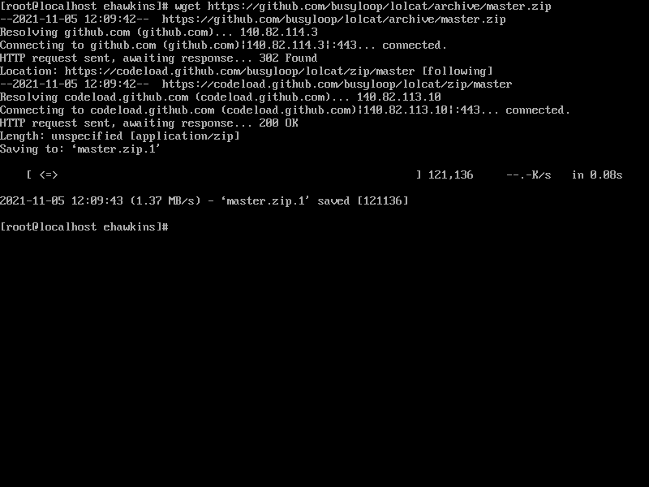

After you finish running this path we must extract, install, and run lolcat.

To do that we are going to use the command unzip master.zip. After that we are going to install lolcat using gem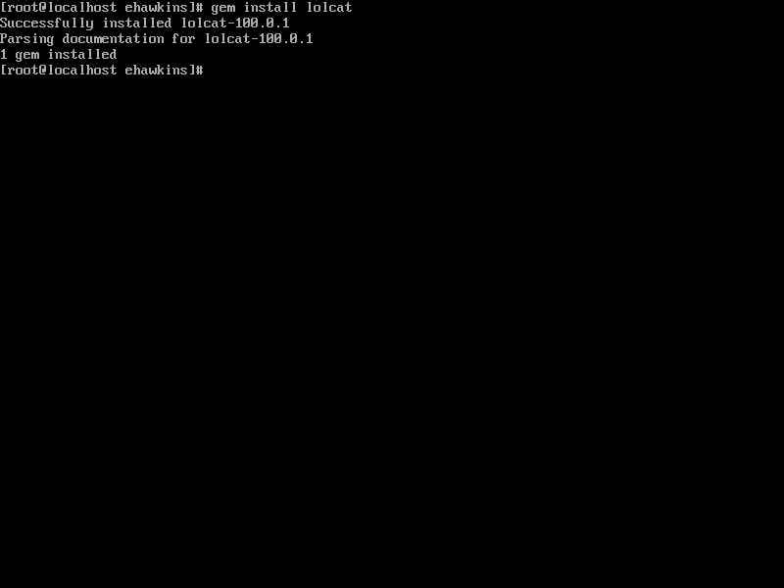

After that we are going to test it to see if lolcat works. If lolcat is installed correctly the cow will be colorful.

For that we are going to pipe what the cow would say to lolcat.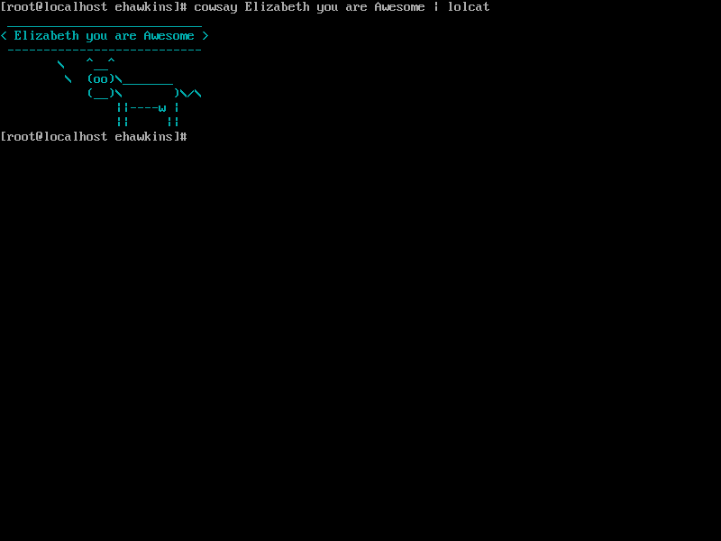

If you want to get a list of all your repositories you use the command yum repolist

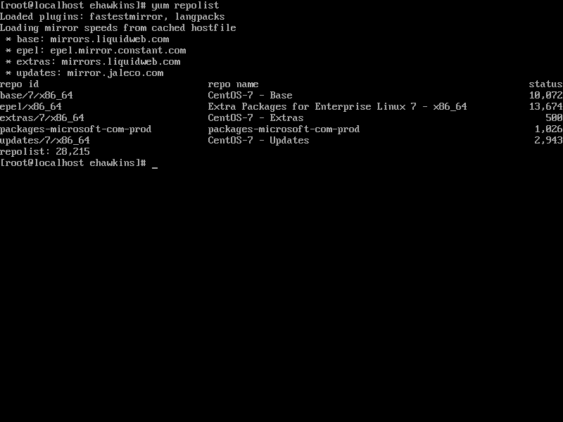

Step 6

Update Vi to Vim

To update Vi to Vim you use the command sudo yum install vim. Vim was already set to the latest version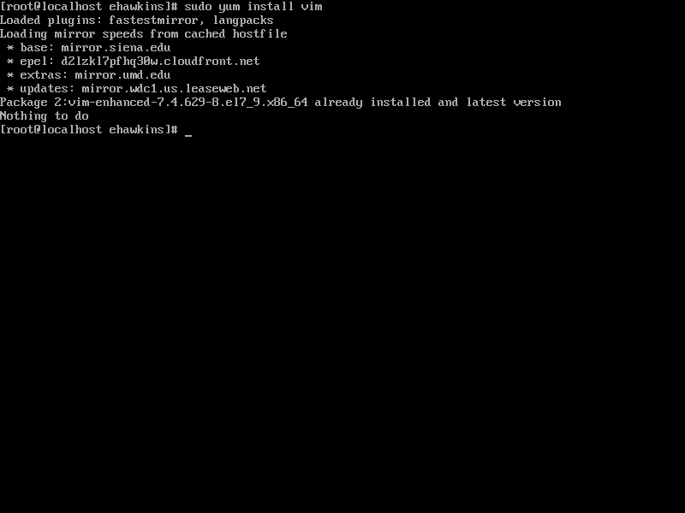

To check to see if the latest version is working you type Vim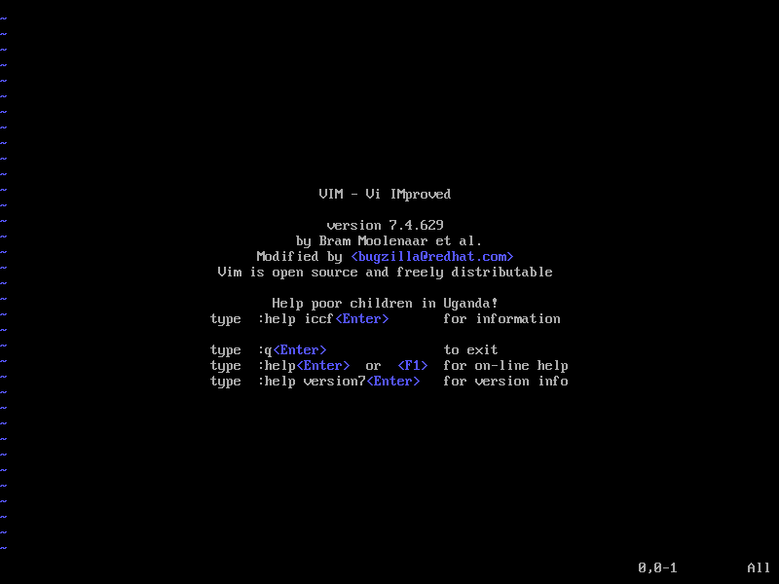

To find the location of the programs you already installed and where can be found we are going to use the which command.

Which command is used to locate the executable file associated with the given command.

To find our installed packages we have an RPM tool that can be used. We must use the grep command and the pipe to search for every one of the packages already installed.

For this you will run the command like this.

rpm -qa –last | grep lolcat

rpm -qa –last | grep tmux

rpm -qa –last | grep emacs

rpm -qa –last | grep cowsay

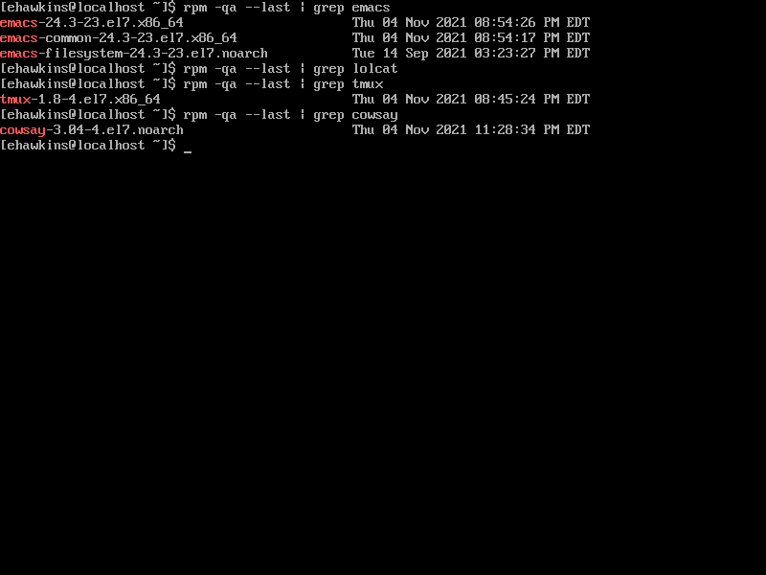

Resources

YouTube

Learning Modules

Techmint.com